Contents

Group Proposal 2

Members: Drishti, Richa, Sicong and Mark 2

Topic Rationale 2

Datasets and data providers 2

Link to Primary Github Repo: https://github.com/MarkovCredit/UCI_DRSM_Project2 2

Concept 3

Visualizations 4

# Group Proposal

# Members: Drishti, Richa, Sicong and Mark

## Topic Rationale

In efforts to aid fellow budding data scientists in their arduous job hunt, we will be building an interactive visualization to dynamically summarize all things focused on data science and analytics careers. From a global view, the user should be able to see in one screen visual summaries of important career and job metrics across the U.S. Leveraging tools we have learned in class including D3, Plotly, Beautiful Soup, Mongo, Flask and HTML/CSS, we will enable users to interactively plot key career indicators most important to them. We have found preliminary datasets (provided below) and will also explore scraping key websites including Linkedin, Glassdoor, Indeed and others.

## Datasets and data providers

1. <https://www.kaggle.com/PromptCloudHQ/us-jobs-on-monstercom>
2. <https://www.kaggle.com/PromptCloudHQ/us-technology-jobs-on-dicecom>
3. <https://www.kaggle.com/jonatancr/data-science-jobs-around-the-world>
4. Linkedin.com
5. Glassdoor.com
6. Indeed.com

## Link to Primary Github Repo: <https://github.com/MarkovCredit/UCI_DRSM_Project2>

# Concept

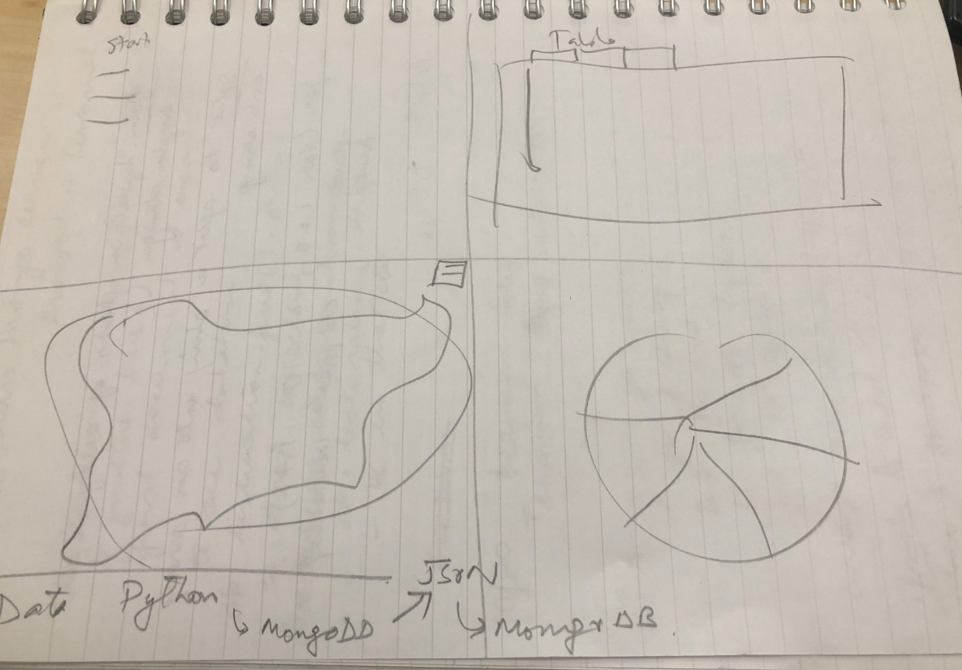

## Visualizations

